Requirements Engineering - Worksheet
Avinash
Consider the following case study:
A university plans to develop a University Academic Portal to improve communication and streamline academic activities for students and faculty. Currently, many processes such as checking grades, viewing attendance records, and sharing course-related information are handled through separate systems or manual methods, leading to delays and confusion. The proposed portal should allow students and faculty members to log in using their university credentials and access relevant academic information. Students may be able to view details such as their grades, attendance, course schedules, and important announcements, while faculty members may have options to upload marks, manage attendance, and communicate with students. The system may also support administrative activities such as updating course information and maintaining academic records. The university expects the system to be accessible online and usable across common devices.
Given this scenario, list out all the functional and non-functional requirements before proceeding!

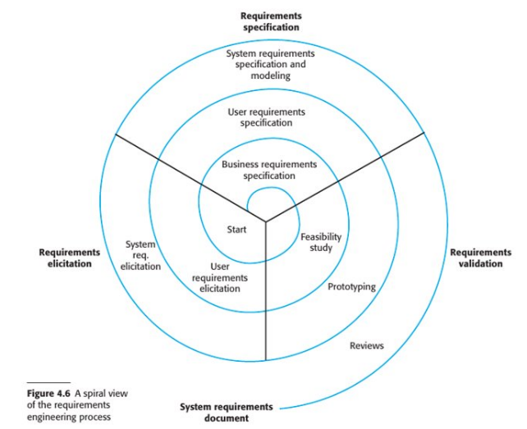
Is this fair? (can you truly capture requirements in this manner?)
Do you think you can capture all requirements in one go?
Do you think you do not need discussions with various stakeholders before finalizing requirements?
If your answer to any of the questions above is YES, then maybe you need to pay more attention to Software Engineering classes!
Requirements gathering never happens in a linear fashion, in one go. In most cases, it is iterative, meaning it happens in cycles, meaning there are discussions and counter discussions where the requirements are identified in an abstract manner, then refined, some are dropped, some are pushed for future iterations and so on.
Output: Formal requirements document
Once you have your discussions, you have an idea about what your requirements are. This phase where you try to understand and discover requirements is called REQUIREMENTS ELICITATION.
Okay, now you have some idea of what all features (functional requirements) your system should have, and what are the operating constraints (non-functional requirements). But we have only limited memory, and it is not a good idea to hold everything in our heads. We need to document all these requirements somewhere. Further, documenting requirements makes sure that everyone understands what the requirements are (once they are listed down, I realize that my idea of login functionality – say OTP based, did not align with the customer’s idea of login – Google based). This process of putting requirements in a particular format is called REQUIREMENTS SPECIFICATION.
Once all the requirements are put in place, they need to be validated. That is nothing but making sure that the requirements are complete, not contradictory, are doable within the given time frame and so on. This part of requirements engineering is called REQUIREMENTS VALIDATION.
If you notice the diagram on REQUIREMENTS ENGINEERING, you notice that requirements are done iteratively. Now the number of iterations depend on the project.
In case you are doing requirements engineering for a new navigation software for an Airbus commercial jet, would you have more spirals (iterations) or less iterations when compared to a) building a university portal? b) building a video game? c) building a food delivery app?
For the given university portal, rank the order in which you would spend time in requirements gathering
a) Understanding the user requirements
b) Understanding the bigger picture – do we need this software for the university
c) Understanding the system requirements
d) Understanding the non-functional requirements
Given you have severe time constraints on the project, will you spend a lot of iterations understanding requirements or will you proceed with a basic understanding?
Can requirements change? Once developers start coding do they think some requirement can be better? What if the underlying software that the system runs on changes? What if the hardware changes? What if the VC of the university went abroad and saw the portal of an university abroad, and comes back with some new requirements for his university portal?

Right? You see what I am hinting at?
So change is possible, nay inevitable! How do we deal with change?

Intuition will tell you that if you have requirements listed down somewhere and mention somewhere that requirement x and requirement y are dependent, changes in x will impact y. So when you do make changes to requirements, you will know the effort it takes to include or incorporate change. We will look more at this in REQUIREMENTS MANAGEMENT
Now let’s go step by step in the different phases of the cycle of requirements engineering (remember the previous diagram)
1. Business Requirements Specification (BRS) – The bigger picture:
Why do we even need this software? Who will benefit from it? What should the system do? (high level)
2. Feasibility Study:
Some questions thrown up in BRS can be answered during the Feasibility study.
As the name suggests, feasibility study is used to answer how feasible it is to develop the system.
Feasibility (noun): “the possibility that something can be made, done, or achieved, or is reasonable” (Cambridge English dictionary)
Types:
- Technical: Can it be done using existing tech?
- Economic: Financially viable?
- Operational: Will people even use it?
- Schedule: Can it be developed in time?
- Legal and Compliance: Will it satisfy legalities (Example: I want to make an app to track professor movement on campus, so that I can know where they are at any particular moment, making meetings easier; BUT will this not open up uncomfortable questions on data/ location privacy, are we allowed to know someone else’s location 24x7?)
3. Requirements Elicitation:
Elicitation: “the formal process of drawing out, evoking, or extracting information, responses, or reactions from people” (Cambridge English dictionary)
Software Engineers work with stakeholders to find out:
a. Where the application should work? (domain – university, hotel, etc.)
b. What activities are usually performed?
____________________________________________________
____________________________________________________
____________________________________________________
c. Functional and Non-functional requirements
____________________________________________________
____________________________________________________
d. Hardware constraints
____________________________________________________
Challenges in this phase
a. Stakeholders do not know what they want (except in abstract sense)
Eg: "We need a system where students can register for courses"​ - Can they edit (add/ drop)? Prerequisites? What if some course is full? Are there limits?
b. Stakeholders express requirements in their own way.
Eg: We need a system that supports a curved grading policy! – Professor X – What is the problem with this requirement? ____________________________________________________________
c. Different stakeholders express requirements in different ways (contradictory) –
Eg: ____________________________________________________________________________
d. Economic and business environment.
Eg: REQ: “Use credit and debit card”, In 6 months government makes UPI mandatory and it is popular and everyone uses it. What is the problem now? ________________________________
Phases in REQUIREMENTS ELICITATION
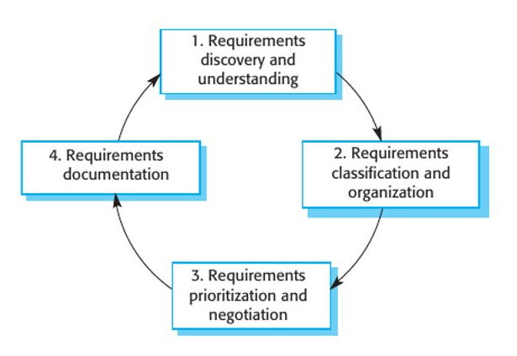
Why do we need to prioritize and negotiate requirements here?

Requirements elicitation techniques:
a. Interviews
- Can be formal or informal
- Can be open (open ended questions) or closed (fixed set of questions predetermined) – generally it is a mix of both
- In this scenario (portal), what questions would you ask your client? List some of them down below
- Challenges: People may disclose information in a very technical manner (tech jargon), may not disclose some company or organizational practices
- Try to ask spring-board questions (examples listed below):
What problems do you currently face with the existing system?​
Can you walk me through a typical day using the current process?​
What frustrates you the most?​
What happens when something goes wrong?​
If this system failed, what would be the biggest impact?
b. Observation and Ethnography
- As the name says, you observe the customer at his organization to get a better idea of where the proposed software will be used, talk to the people who will use the system
Examples:
* You visit the classroom at the end of the class and notice that QR based system needs to be faster, responsive and give more time to scan code
* You go to a supermarket and observe or ask customers whether they will actually spend time to scan product barcode and care about the ratings
* You go to labs at convention center and notice that Internet there is weak, and using the portal will be difficult (so QR scanning page of the app should use minimal styles, be easy to load, etc.)
- Ethnography is highly important especially in cases when there is already a system in place and you need to understand from the existing system what its failures were and how it can be improved
Along with these 2 techniques, can also use existing documentation of existing software (in case your new software is an upgrade of existing software)
You use stories and scenarios to tools to describe findings from ethnographic studies:
Example story:
“During observation in the Computer Science department, a requirements analyst notices that many students frequently visit faculty offices to ask about their attendance status. Faculty members maintain attendance in personal spreadsheets and upload them to the department system only once every two weeks. Because of this delay, students often do not know their real attendance percentage until it is almost time for exams. Some students depend on classmates or messaging groups to estimate their attendance. This situation causes confusion and unnecessary communication between students and faculty.”
Example scenario:
Actor: Student
Preconditions:
- The student has a valid university account.
- The student is enrolled in at least one course.
- The university portal system is accessible.
- Attendance records for the course have been uploaded by the faculty (may or may not be up to date).
Main Steps (Scenario Flow):
- The student opens the University Portal.
- The student enters login credentials.
- The system verifies the credentials.
- The system displays the student dashboard.
- The student selects the Attendance option.
- The system displays a list of the student’s registered courses.
- The student selects a specific course.
- The system displays the attendance percentage and class-wise attendance details.
Postconditions:
- The student can view the attendance record for the selected course.
- The system logs that the attendance information was accessed.

What do you think is the advantage of stories and scenarios over asking requirements (what you need?) formally?
4. Requirements Specification:
- Requirements specification was covered in Lecture 5 so I will not repeat those concepts here
- Note: SRS allows room for modification/ customization
5. Requirements validation:
- In simple words, you are checking whether the requirements gathered and specified are what the customer actually wanted
- Different ways to check requirements:
Validity Check:​
Does the portal actually help students register for courses in a way that matches their real needs
Consistency Check:​
If one requirement states that students can reset their password via email, another requirement should not say that password resets are only possible through the IT helpdesk​

Completeness Check:​
The student portal requirements should include course registration, fee payment, grade viewing, and any necessary constraints (e.g., prerequisite enforcement)​
Realism Check:​
A requirement that says "The student portal should process 1 million registrations per second" is unrealistic given the university’s current infrastructure and budget​
Verifiability Check:​
The system should allow students to reset their password within 5 minutes of requesting a reset link (this can be tested and measured)​
- How do you check requirements though?
a. Team of reviewers
b. Prototyping? How does this help:_____________________________________________________
c. Test case generation
- How does test case generation help?
a. Checks functional coverage! (okay, I am tired typing all this over the last 2 hours, just ask me, your instructor, what this point means!)
b. Identifies ambiguous requirements. Example: REQ1: Allows users to reset password. What is the problem here? ____________________________________________ (hint: what is a valid password)
c. Incorrect or conflicting requirements. Example1: "Users must be logged in to view reports," but another says, "Users can access reports without logging in." Test cases will reveal this inconsistency, Example2: One requirement says, "Students must be able to register for any course at any time, without any restrictions." Here the test case might reveal that the requirement is incorrect since universities allow registration only at start of semester
d. Ensures requirements are verifiable. How? _____________________________________________
e. Validates business logic and user scenarios. Example: A test case simulates students accessing their grades to verify that only authorized students can view them, or only authorized professor(s) can assign and publish grades.
6. Requirements Management:
- Sad (or happy) reality of the world is that requirements are always changing
- Sometimes requirements are wicked (we will see an example. Imagine Jafar, the vizier smiling)
- New requirements emerge post deployment. Example: _________________________________
- Changes in business environment (we will see reasons below)
- Wicked changes
Requirement: "A university wants to implement a Dynamic Student Feedback System in a university portal"​
Hard to define! Why? Student expectations, faculty preferences, university policies are evolving​
Initially – End of semester feedback​
Then – students request removal of forced feedback (having to provide feedback for profs who do not teach them)​
Then – Some course faculty consider real-time mid semester feedback​
Then – Administration says bias and misuse might happen with dynamic feedback (but then faculty says no problem, we will have moderation)​
Then – Admin says why not have AI based sentiment analysis, but privacy regulations come in the way (can you really take something shared discreetly and in privacy and feed it to a system?)​
These shifting needs make it difficult to finalize a stable set of requirements, leading to continuous modifications in the system

- Changes in business environment
The business and technical environment of the system always changes after installation. New hardware may be introduced and existing hardware updated (new OS has packages which are incompatible with software). Business priorities may change (use cisco webex instead of messenger)​
The people who pay for a system and the users of that system are rarely the same people​
Large systems usually have a diverse stakeholder community, with stakeholders having different requirements

- Requirements Management keeps track of individual requirements and maintain links between dependent requirements so that you can assess the impact of requirements changes
- Users may not be the best judge of change and which requirements should stay and which should go, so sometimes an independent authority makes these calls
To manage the changing/ evolving requirements, we need some way to maintain traceability links (what requirements are related to what requirements).
Requirement ID​ | Requirement Description​ | Related Module(s)​ | Dependency​ | Status​
REQ-101​ | Update grading policy to include Pass/Fail option​ | Grading System​ | Affects GPA calculation, transcript generation​ | Approved​
REQ-102​ | Modify GPA calculation logic for Pass/Fail courses​ | GPA calculation​ | Dependent on RQ-101​ | In Progress​
REQ-103​ | Update transcript format to reflect Pass/Fail grades​ | Transcript Generation​ | Dependent on RQ-101​ | Pending​
REQ-104​ | Ensure academic standing rules account for Pass/Fail courses​ | Academic standing module​ | Dependent on RQ-102​ | In Progress​
REQ-105​ | Modify course eligibility checks to support Pass/Fail prerequisites​ | Course Registration​ | Dependent on RQ-101​ | Approved​
REQ-106​ | Update student and faculty portals to display Pass/Fail grades​ | Student and Faculty Portal UI​ | Dependent on RQ-101 & RQ-103​ | Pending​

For the given case, can you make a traceability matrix?
In a university portal​, Initially - course registration system allows students to enroll in courses based on prerequisites​, Then - university introduces a waitlist feature, requiring changes to enrollment logic (wait for a while before finalizing courses)​, Then - administrators request automated prerequisite overrides for exceptional cases, impacting both the registration and waitlist modules.

- Requirements Management Planning:
During the planning stage (within RE), decide on:​
* Requirements identification: Each requirement should have a unique ID
* Change management process: Set of activities that assess the impact and cost of changes
* Traceability policies: Help link related features (using tools like traceability matrix)
* Tool support: Since this task can get tricky, you can decide on what tools to use for automation support before starting requirements planning​
7. Requirements Prioritization:
- Triage
- MoSCoW
- Kano
In the student portal, which requirements can be “Could haves” as per MoSCoW?

